Reading Curriculum Coverage – UKS2
Developed by: Year 5 & 6 Compiled: March 2022
Cycle A – Academic Year 2021-2022
Year 5 / 6
Autumn 1 | Autumn 2 | Spring 1 | Spring 2 | Summer 1 | Summer 2
Off with her head!  (History Driver) | Frozen Kingdoms  (Geography Driver) | Tomorrow’s World  (Computing Driver) | Maya  (History Driver) | Darwin’s Delights  (Science Driver) | Year 6 – Maafa  Year 5 - Britain at War  (History Driver)
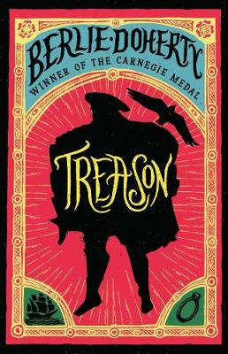  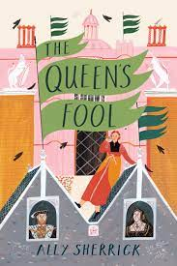 | 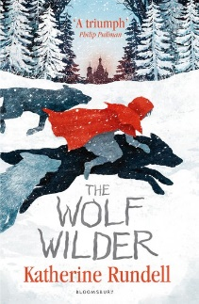  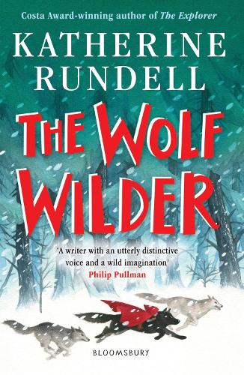 | 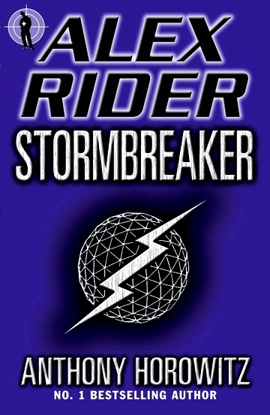 | 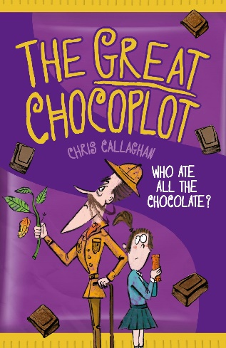 | 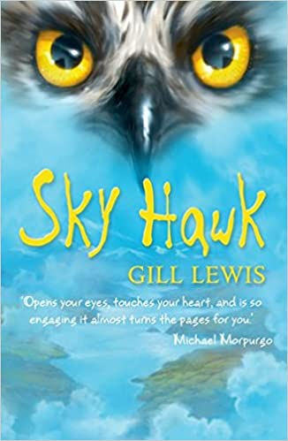 | 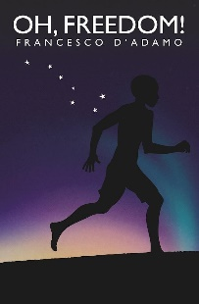  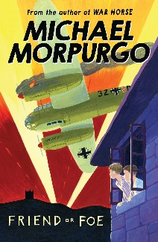
Year 6 – Treason by Berlie Doherty  Year 5 – The Queen’s Fool by Ally Sherrick  (Historical Fiction) | The Wolf Wilder by Katherine Rundell  (Historical Adventure) | Stormbreaker by Anthony Horowitz  (Action Adventure Story) | The Great Chocoplot by Chris Callaghan  (Modern Dilemma Story) | Skyhawk by Gill Lewis  (Animal Adventure Story) | Year 6 - Oh, Freedom! by Francesco D’Adamo  Year 5 – Friend or Foe by Michael Morporgo  (Historical Fiction)

Cycle B – Academic Year 2020-2021 & 2022-2023
Year 5 / 6
Autumn 1 | Autumn 2 | Spring 1 | Spring 2 | Summer 1 | Summer 2
Sow, Grow & Farm  (Geography Driver) | Shang Dynasty  (History Driver) | Alchemy Island  (Science Driver) | Stargazer  (Science/Computing Driver) | Time Traveller  (A&D/T/PHSE/Science Driver) | Glorious Greeks  (History Driver)
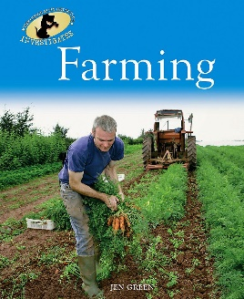  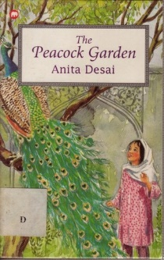 | 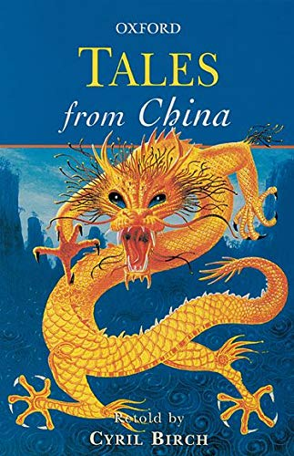 | 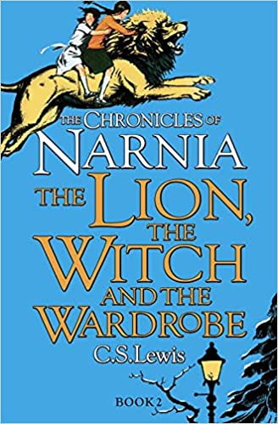 | 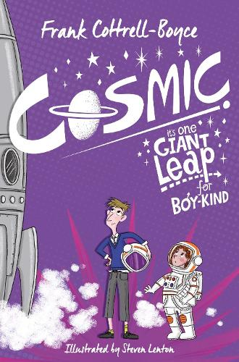 | 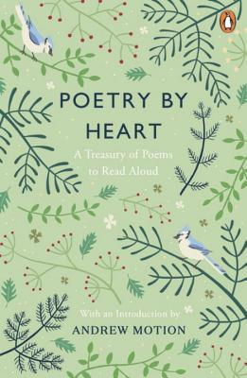 | 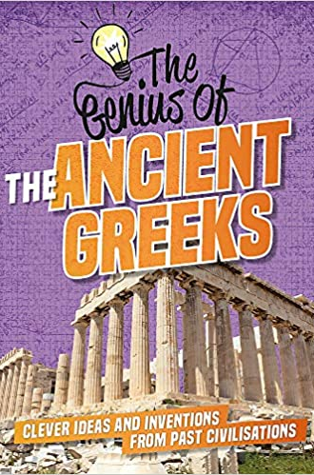
Farming by Jen Green  (Non-Fiction)  The Peacock Garden by Anita Desai  (Historical Fiction) | Tales from China Retold by Cyril Birch  (Cultural Short Stories) | The Lion, The Witch & The Wardrobe by C.S.Lewis  (Fantasy Fiction) | Cosmic by Frank Cottrell=Boyce  (Science Fiction) | Poetry by Various Poets  (Poetry: Sonnets, Limericks, Haiku & Free verse) | Eye Witness Ancient Greece By DK  (Non-Fiction)

