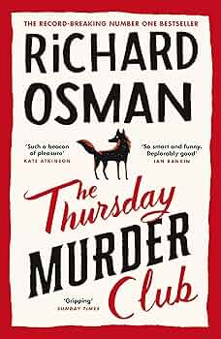
Mrs Phillips' Recommended Read for Adults - January.

This book is just the first in a series of four. I read the latest of these four over the holidays and thoroughly enjoyed every page of it.
All four of the books follow the same group of elderly (but exceptionally capable) individuals who live within a retirement complex near the Kent south coast. Elizabeth (an ex MI5 agent who has contacts everywhere), Joyce (a lovely lady looking for companionship), Ron (an ex-boxer) and Ibrahim (a physiatrist in a previous youth) all join together to help get to the truth of a brutal killing that happens right on their doorstep.
An easy but gripping read from book 1 to book 4.

Thursday Murder Club by Richard Osman

