JIGSAW Our PSHE Curriculum
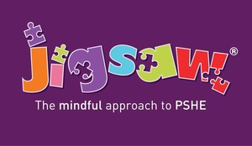
Jigsaw PSHE
What is Jigsaw PSHE?
Jigsaw PSHE is a comprehensive and completely original Scheme of Work for the whole Primary School from Years F1 and 2 through to Year 6. It brings together PSHE Education, emotional literacy, social skills and spiritual development in a comprehensive scheme of learning.
SMSC (Spiritual, Moral, Social and Cultural) development opportunities are mapped throughout. All of these pieces of learning are brought together to form a cohesive picture, helping children to know and value who they are and understand how they relate to other people in the world.
British Values
Jigsaw contributes, as a good PSHE programme should, to the British Values agenda very significantly, both through the direct teaching of information and through the experiential learning children will enjoy.
The 5 strands of the British Values agenda have been mapped across every Puzzle and every Piece (lesson).
We link our whole school assemblies and our Friday Golden Assembly to the Jigsaw Themes and Values being taught and applied through the PSHE curriculum. We are proud of the way we promote emotional wellbeing for all our pupils through our Jigsaw programme which underpins the whole of our curriculum.

