**Science Year 5**

**Living things and their habitats. (Biology)**

In Year 4 I knew….

* Recognise that living things can be grouped in different ways.
* Explore and use classification keys to help, group, identify and name a variety of living things in the local and wider environment.
* Recognise that environments can change and that this can sometimes pose dangers to living things.

This year I will know….

• Describe the differences in the lifecycles of a mammal, an amphibian, an insect and a bird.

• Describe the life process of reproduction in some plants and animals.

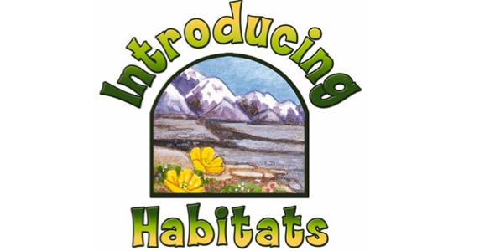

I will use this knowledge in Year 6 to ….

• Describe how living things are classified into broad groups according to their common observable characteristics and based on similarities and differences, including microorganisms, plants and animals.

• Give reasons for classifying plants and animals based on specific characteristics