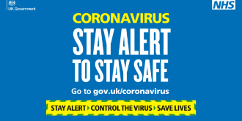
Stoneydelph Primary School
Summary of Covid – 19 symptoms and procedures for testing

Symptoms to look out for are:
- persistent cough (or several prolonged coughing episodes in 24 hours)
- high temperature (child may feel hot to the touch on back or chest)
- loss of taste or smell
These are also classic symptoms of other viruses but it is important to be vigilant and follow the procedure below if your child displays these symptoms.

What to do:
- Contact school and let us know
- Keep your child and any siblings at home. The household should self-isolate.
- Book a Covid-19 test (online at www.NHS.co.uk or call 111 if you cannot book a test online)
- Let us know the result as soon as you can
- Whilst the children are self-isolating, a paper learning pack will be delivered and further home learning set on Class Dojo.

If the test is negative:
- Children can return to school the following day if they are feeling well.

If the test is positive:
- The person with symptoms should isolate for 10 days
- The rest of the household should isolate for 14 days
- School will inform Public Health England and they will decide if the child’s ‘bubble’ should close. This will include all classes from that age phase (eg Y1/2, Y3/4, Y5/6 and Early Years) School will follow the advice given from Public Health England.
- If any class bubble is closed, a paper home learning pack will be sent home on the first day of closure and future home learning will be set on Class Dojo.
- If the child’s class teacher or a member of staff in the ‘bubble’ has a positive test result, school will also contact Public Health England and follow advice regarding closure of the ‘bubble’.

After the required period of isolation the child will return to school and the bubble can be reopened. Information regarding school closure will be communicated with parents via Parent Text, Class Dojo and the school website. Please check for updates regularly.
Thank you for making our school Covid Secure.

