This year I will ….

* Use some simple scientific language.
* Begin to use science words.
* Use comparative language with support.

**Science Year 1**

**Vocabulary**

**Working Scientifically**

In EYFS I ….

* I was introduced to some simple science words

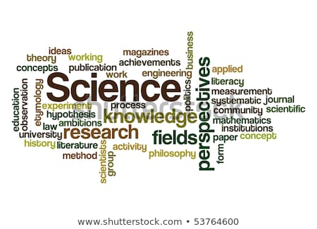

I will use this knowledge in Year 2 to ….

* Use simple scientific language.
* Use comparative language – bigger, faster, heavier.