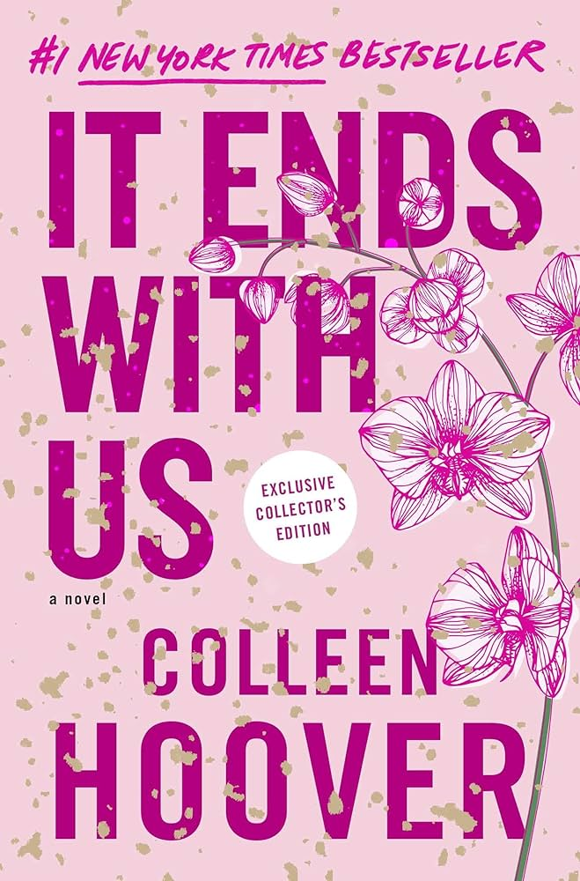
Mrs Collins' Recommended Read for Adults - October.

I'd recommend It Ends with Us by Coleen Hoover. I couldn't put this book down, it has twists that are totally unexpected. The story follows a girl named Lily who has just moved and is ready to start her life after college. Lily then falls for a neurosurgeon named Ryle. As she is developing feelings for Ryle, Atlas, her first love, reappears and challenges the blossoming relationship between them.

It Ends with Us by Coleen Hoover

