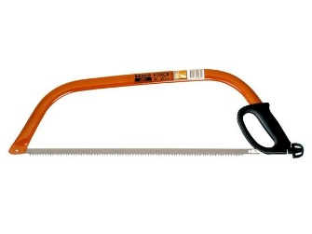
RISK BENEFIT ASSESSMENT – Bowsaw
Low risk- Something resulting in a minor injury eg a scratch or a bruise
Medium risk- something resulting in significant loss/ damage or an injury such as a broken bone which requires hospital treatment
High risk- something that results in extensive loss/ damage, multiple injuries or death
Location/ Activity: | Stoneydelph Forest School | Date: | December 2021
FS Leader: | Mrs J Parry | Review Date: | December 2022

Activity | How will young people BENEFIT from the activity? | Possible Hazards | Overall risk ratings  Low/ Med/ High | Who is at risk? | Precautions in place to reduce risk of injury | Risk rating following precautions
Transporting the bowsaw | Children having the opportunity to select, collect and return their own tool gives them a deeper sense of ownership over the activity | Dropping of the tool/damaging it  Bruises to child if dropped on themselves  Bruises to other children if passing too closely | Low | Young people/ adults | Tool talk to demonstrate/  verbally state correct carrying procedure  Children only allowed to carry tool away from tool storage area in the correct holding position  Clear adult modelling | Low
Removing the cover from the bowsaw | Removing the cover safely and independently gives the child opportunity to assess the risk for themselves and carry out their own safety check. This includes the safety of other children as they need to check that other children are a safe working distance away. | Cuts or lacerations from the blade | Medium | Young people/ adults | Tool talk to demonstrate/verbally state the correct cover removal procedure  Adult to remove cover until learners have shown a good level of manual dexterity | Low
Cutting with the bowsaw | Use of the bowsaw will enable children to produce woodland crafts and manage the site, which gives purpose to their time in the woodland environment (due to the fact they are having an impact) | Cuts or lacerations from the blade | Medium | Young people/ adults | Anyone using the tool will wear a glove on the non-tool hand in case it ‘bounces’  Tool talk to include 3 back cuts before beginning to saw so that the blade settles into the groove  Users advised to pull towards themselves rather than pushing towards the other person  Adult may support the bowsaw to ensure it doesn’t ‘bounce | Low
Cleaning the bowsaw | The learners will understand the method for safely cleaning and packing away tools. | Cuts or lacerations from the saw blade | Medium | Young people/ adults | Learners will be shown a range of safe cleaning methods  Gloves may still be worn if required/ advised  All cleaning should happen in a stable seated position | Low

Format edited from: http://www.learningaway.org.uk

