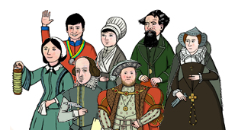

This year I will know….

* About significant Tudor leaders such as Henry VIII and how they led their people into battle and compare to Roman/Viking soldiers and battles and conquests
* About Ancient Egyptian Pharaohs and compare to Emperors from other Ancient civilisations (Maya / Shanghai)
* Know about significant figures from Tudor Era how they brought about social reform and change which then impacted on modern life.
* Know about significant figures from the Victorian Era and during WW2 how they brought about social reform and change which then impacted on modern life.

**History Year 5 / 6**

**Learning about the lives of significant people**

* Town Planner
* Archaeologist
* Film maker
* Politician

In the future this knowledge could help me to become a…

* Museum curator
* Historian
* Journalist
* Teacher

In Year 3 and 4 I knew….

* about Anglo Saxon/Roman invasion and key figures such as Julius Caesar and Boudicca and how they impacted on the world.
* about the leaders of invasion and exploration from Tudor times to Viking/Roman invasion and exploration
* about Stone Age Man and Native American Indian Tribes and how this life has shaped the modern day