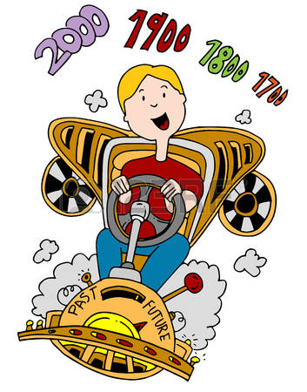

This year I will know….

* How to use the words yesterday, today, then, now, before, after, old and new
* How to describe events using time words (chronological vocabulary)
* Sequence 3 - 5 stories, events or objects using chronological order and time words to explain the sequence
* Talk about mine and other people’s past events using common time words such as tomorrow, a long time ago, in the olden days, before and later
* How to use different sources (books, photos, maps, internet etc) to find out about the past.
* Use a simple timeline to sequence monarchs using key dates to support chronology.

**History Year 1 / 2**

**Chronology and Timelines**

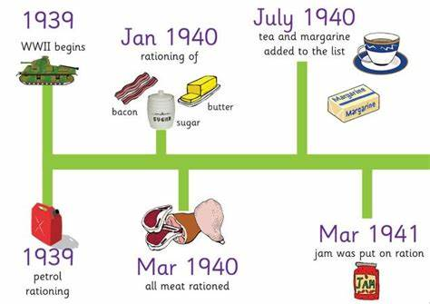

In EYFS I knew….

* About past and present events in my life and my family members.
* Use time words such as now, next, before, after, today, tomorrow
* Stories from the past such as: traditional tales
* How to sequence 2 objects, people or pictures using time vocabulary such as young/old or old/new first/last

I will use this knowledge in Year 3 / 4 to know….

* Show developing understanding of chronology by beginning to realise that the past can be divided into different periods of time.
* Use specific historical vocabulary including terms and periods – AD, BC, Modern, Ancient
* Use a timeline to categorise key features of specific time periods (people and places) and describe how they are different and similar to the present day.
* Use specific historical vocabulary including terms and periods empire, military ancient, exploration, civilisation.