Thumbs up for our space learning!

Stoneydelph Newsletter
Learn & Achieve

Diary Dates
Thurs 10th Oct EY & KS1’Come and read in class with your child’ 2.30 – 3pm

Mon 14th Oct KS2 ‘Stay and read in class with your child’ until 9.30

Tues 15th Oct Individual and family photographs – details to follow

Wed 16th Oct Phonics meeting led by Miss Fox for parents of children I YrR / Yr 1 in KS1 hall 9am

Thurs 17th Oct
Yrs 2 – 6 trip to National Space Centre in Leicester

Thurs 17th Oct invite to parent / grand-parent to join your YR or Y1 child for lunch. (see separate letter for details)

Monday 21th – Thursday 24th Oct ‘Space Week’

Thursday 24th Oct Halloween Discos

Friday 25th Oct INSET Day – school closed to children - staff at school for training

Monday 28th Oct to Friday 1st Nov school closed for half term

Tues 12th & Wed 13th Nov Parent Consultation Evenings – details to follow.

Stoneydelph primary school 11th october 2019
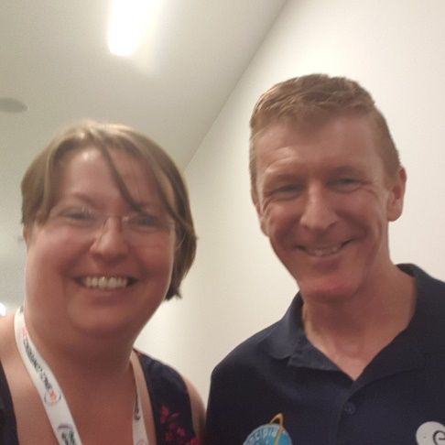
We were delighted that Mrs. Gill was recently invited to share our children’s learning at the STEM Space Learning Conference in Cardiff. The conference included representatives from schools all over the UK and Europe. Learning examples from across all year groups was on display and Mrs. Gill received numerous compliments for the standards of our children’s learning. Added to this, she had the opportunity to meet and chat with Tim Peake about the Space Learning opportunities we have offered in school - he was impressed and expressed his best wishes for another successful Space Week later this term.
MacMillan Coffee Morning Thank you to all the parents who brought in cakes for our MacMillan Coffee Morning. Thank you also to all the parents who came to share the occasion and support the worthwhile cause, we raised £140.86. Our thanks also go to the PTA for organising the event.
Helping our children to be healthy Good hand washing hygiene is essential in school to help stop nasty bugs spreading amongst the pupils and staff.
Washing your hands properly should take about as long as singing "Happy Birthday" twice (around 20 seconds). Use the following steps from the World Health Organization while you hum: 1.Wet your hands with water (warm or cold). 2. Apply enough soap to cover all over your hands. You can use alcohol-based handrub if you do not have immediate access to soap and water. 3. Rub hands palm to palm. 4. Rub the back of your left hand with your right palm with interlaced fingers. Repeat with the other hand. 5. Rub your palms together with fingers interlaced. 6. Rub the backs of your fingers against your palms with fingers interlocked. 7. Clasp your left thumb with your right hand and rub in rotation. Repeat with your left hand and right thumb. 8. Rub the tips of your fingers in the other palm in a circular motion, going backwards and forwards. Repeat with the other hand. 9. Rinse hands with water (warm or cold). 10. Dry thoroughly with either a hand-dryer or paper towel. We will be teaching and supporting children to remember this handwashing routine over the coming weeks and would ask you to support this at home – hopefully this will help to reduce the spread of infections over the winter. Thank you for your support with this.

Build Update As you can see, the scaffolding around much of the front of the KS2 building is now down as the roof and elevated sections are near full completion. Although we have opened up the pathway round to the front we would still advise parents / carers and children to take extra care as contractors are still on-site completing the new boiler work, maglocks on the doors and the refitting of the offices area.
As this work continues there will also be deliveries and vehicle movement. Work will also begin on the gates and car park soon. Please continue to take extra care around the school site.
Road Works Highways England have asked us to make parents aware that there will be resurfacing works on the M42 between J9 and J10 Northbound and Southbound over the next few weeks. This may lead to additional congestion on surrounding roads (including Penine Way) particularly early in the morning. The schedule if works is as follows:
- M42 J9 to J10 Northbound 14th October - 20th October, 10pm until 6am.
- M42 J10 to J9 Southbound 21st October - 26th October, 10pm until 6am.
- M42 J10 Southbound exit slip 28th October to 6 November, 9pm until 6am.
If you should require any more information about these closures then call 0300 123 5000 or email info@highwaysengland.co.uk . Alternatively visit the website, highwaysengland.co.uk/roads/.

Applying for a Secondary School Place Children born between 01/09/2008 and 31/08/2009 are due to start Secondary School in September 2020. The deadline for on-line applications is 31st October 2019. Staffordshire residents can make an on-line application for Secondary places at: www.staffordshire.gov.uk/Education You can also search for ‘Staffordshire apply for a school’.
Healthy Eating There has been a great deal in the news over the past few weeks about childhood obesity and encouraging children to have a healthy diet. Schools have been asked to play their part in encouraging this agenda. During their time at Primary School, children will have growth spirts where they will suddenly start growing very quickly and become more active. Children need a healthy balanced diet rich in fruit, vegetables and starchy foods. We should all be eating at least 5 portions of a variety of fruits and vegetables every day. For children, one portion is roughly a handful. We often have children saying they do not want to eat what’s in their lunchbox from home as they don’t like what’s been packed for them – getting your children involved in the planning / buying / packing helps to avoid this. Encourage your child to choose a variety of foods to help make sure they get the wide range of nutrients they need to stay healthy. For further information please visit: Change for life website or contact Staffordshire Families Health and Well-being Service (0-19) East Hub 0300 303 3924

Early Years Open Evening
If your child was born between 1st September 2015 and 31st August 2016, they will be due to start Primary School in September 2020.
Applications for places at Stoneydelph Primary School will open on 1st November and close on 15th January 2020.
Applications are made online at www.staffordshire.gov.uk/education
We will be hosting an open evening on Monday 25th November between 4pm and 6pm for you and your child to visit our Reception classes and discuss our provision.

FHWS.east@mpft.nhs.uk or FHWS.east@nhs.net

Healthy Lunchboxes Top Tips from NHS.....
- Keep children fuller for longer - Base the lunchbox on foods like bread, rice, pasta and potatoes. Choose wholegrain where you can. Sugar based items only provide a very short term energy boost and then leave children craving more.
- Always add veg - Cherry tomatoes, or sticks of carrot, cucumber, celery and peppers all count towards their 5 A DAY.
- Swap the sweets - Swap cakes, chocolate, cereal bars and biscuits for malt loaf, fruited teacakes, fruit breads or fruit (fresh, dried or tinned – in juice not syrup).
- Get them involved - Get your kids involved in preparing and choosing what goes into their lunchbox. They are more likely to eat it if they helped make it.
There will be a questionnaire going out next week where we are inviting parents to contribute to our ‘Healthy Eating Policy’. Please answer the questions honestly and add any comments you would like to be considered. Thank you for your support with this.
Polite Reminder: Please ensure your child’s jumper and coat are named so that if lost it is easy to return. Thank you for your support with this.
Polite request from Year 3 / 4. Please could parents wait on the playground by Year 3/4 rather than on the path as this area has become very congested and it is difficult for the children to exit classrooms safely. Thank you for your cooperation with this.

