This year I will ….

* I am beginning to read, spell and pronounce scientific vocabulary accurately.
* I am beginning to use relevant scientific language and illustrations to discuss, communicate and justify ideas.
* I am beginning to confidently use a wide range of scientific vocabulary.
* I am beginning to use conventions such as trend, rogue result, support predict and ‘er’ word generalisations.
* I am beginning to use scientific ideas when describing simple processes.

**Science Year 5**

**Vocabulary**

**Working Scientifically**

In Year 4 I ….

* I can use some scientific language to talk and write about what I have found out.
* I can use comparative and superlative language.

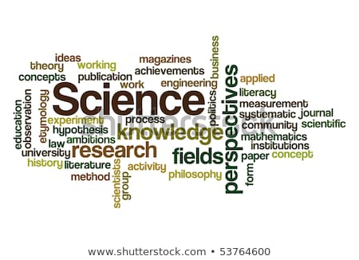

I will use this knowledge in Year 6 to ….

* I can read, spell and pronounce scientific vocabulary accurately.
* I can use relevant scientific language and illustrations to discuss, communicate and justify ideas.
* I can confidently use a wide range of scientific vocabulary.
* I can use conventions such as trend, rogue result, support predict and ‘er’ word generalisations.
* I can use scientific ideas when describing simple processes.
* I can use scientific ideas when describing simple processes.