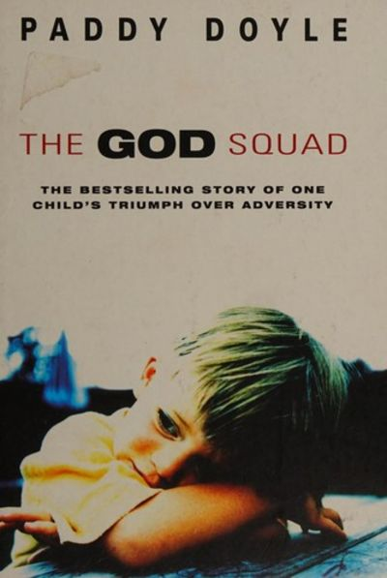
Mrs Packer’s Recommended Read for Adults - December.

The God Squad is the remarkable true story of a survivor, told with an extraordinary lack of bitterness for one so shockingly and shamefully treated. In Paddy Doyle’s own words: ‘It is about a society’s abdication of responsibility towards a child.

The God Squad by Paddy Doyle.

