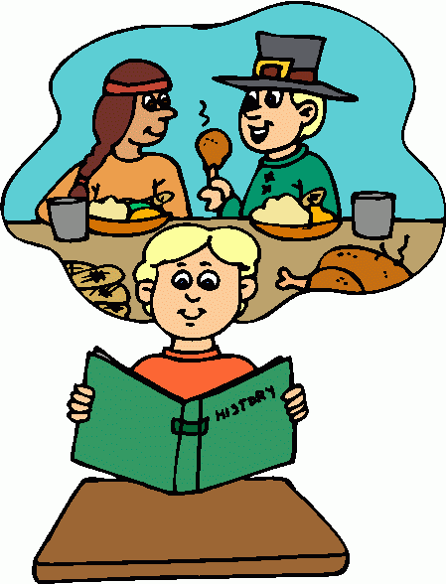

This year I will know….

* That dinosaurs lived in the past and how scientists learnt they became extinct.
* Know the roles and responsibilities of people in medieval times/in a castle/pirate times/Tudor explorers and compare to modern day.
* To learn about my own family tree and those relatives that were alive before me.
* Events in history that changed life today – Great fire of London, Titanic sinking

**History Year 1/ 2**

**Life events beyond living memory**

In EYFS I knew….

* that life in traditional stories from the past was different to life today
* that dinosaurs are creatures that lived a long time ago and are all extinct
* Guy Fawkes and St George was alive in the past
* Family members lived in different types of home and had different hobbies, jobs, food and travel to the way we live today.
* In Year 3 / 4 I will learn…
* About life in the stone, bronze and iron age and how events in modern times helps us to understand life in the past (eg: finding the Lindow man, settlement discoveries
* know about a Roman town in Pompeii, the events of the volcanic eruption and compare to homes in modern day.
* Know about the Indus Valley civilisation and life around 5500 BCE and compare to different civilisations.
* Know about life events in Greece such as; Olympics, Persian War, Battle of Marathon and compare to other events in the past