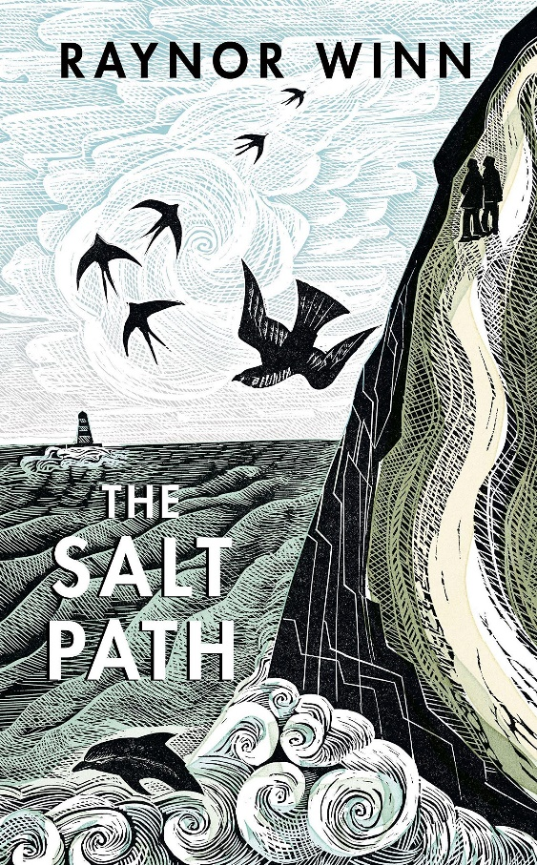
Mrs Phillips' Recommended Read for Adults - September.

I love reading and this summer I've read The Salt Path by Raynor Winn. It tells the tale of a middle aged couple who have lost everything and decide to throw their lives to the wind by walking the South West Coastal Path from Minehead to Poole. It a really gripping read that I could barely put down and even more so if you know the Cornish, Somerset or Dorset Coast. I found myself Googling some of the different locations as I read to follow where the couple were in the journey and to picture the topography of the landscape.

The Salt Path by Raynor Winn

