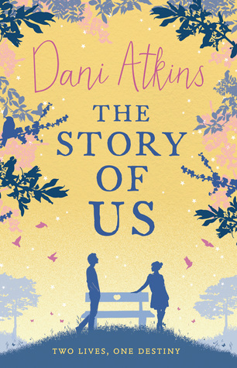
Mrs Radcliffe’s Recommended Read for Adults - November.

A book I quite honestly could not put down! It had me gripped from the first page; a story of love, loss and a brilliant plot twist. If you like books by Jodi Picoult, this will not disappoint. Emma - the protagonist - is such a likeable character and one that so many can relate to. The book begins with action from the very first chapter and you as a reader are left thinking 'what next' so many times. I've read another book by this author (Fractured) and can't wait to read more.

The Story of Us by Dani Atkins.

